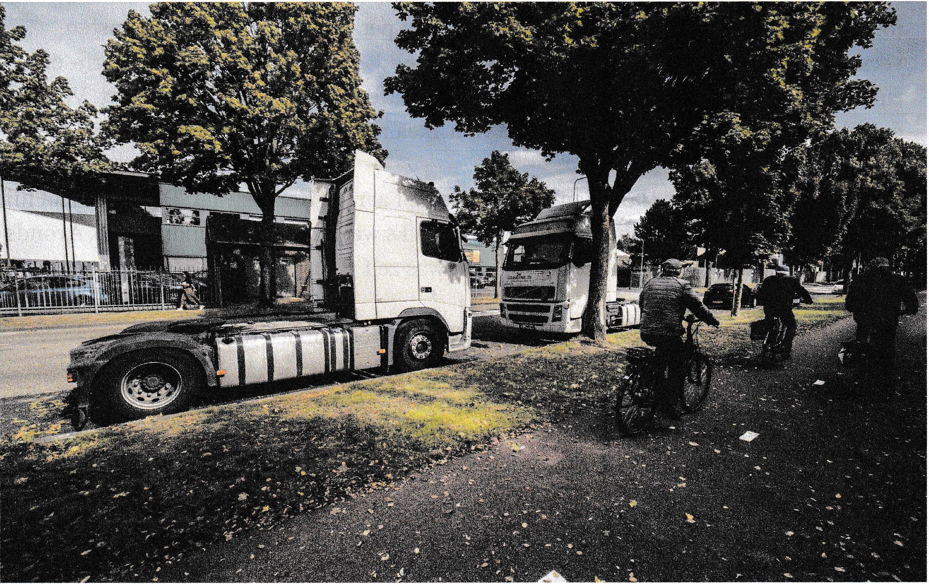
The Kampstraat in Geleen.
© Mitchell Giebels

DRIVER MALPRACTICES
‘You can smell the faeces when you cycle round there’
During a check on the Kampstraat in Geleen, inspection services found lorry drivers living in the car park without a toilet, shower or electricity. They sometimes lived in their cabins for eight weeks. A report follows.

BY MONIQUE EVERS

This Thursday, three lorries stand parked along the parking strip on the Kampstraat in Geleen. Their number plates are from Romania and Lithuania, just like the delivery vans in the area. However, the drivers are nowhere to be found.
“You really should come back at the weekend”, says a man who works across the street. Then, according to him, there will be dozens of lorries, with drivers cooking outside. They will be relieving themselves in the bushes. There is no shower.

It’s like in the Middle Ages, concluded FNV-Stichting VNB [a transport union and member of the Dutch Federation of Trade Unions working to ensure compliance with the Haulage Collective Agreement], which got inspection services in on the act. The drivers work for EUR 65 a day, and inspection services suspect that they receive no holiday pay and that they don’t adhere to the driving and rest periods. This week an investigation began into eight drivers. According to the union, these are drivers who operate journeys for IKEA, but more companies are bound to be implicated.
Roy Breidenbach has run his firm on Kampstraat for thirteen years. Every day, during the daytime, he sees foreign drivers in their lorries waiting to be hired. They spend evenings and weekends in their lorries. He himself witnessed the checks by inspection services.
The number of lorries parking here has increased over the past ten years, says Breidenbach. “During the week there are sometimes about six, but at the weekend easily forty or fifty. You can sometimes smell the faeces when you cycle down the street. At weekends they cook their food on gas burners. They also hang their laundry. It looks like a campsite. It’s sad because these people have no choice.”

Switching hauliers
Edwin Atema of FNV-Stichting VNB received a phone call yesterday morning from IKEA’s head office in Switzerland. “They wanted the hauliers’ names. We didn’t oblige, of course, because they would simply switch from one haulier to the next. If they really want to solve the problem, they will have to do it in collaboration with the unions.”
IKEA will inform De Limburger in writing “as soon as it launches an investigation into these malpractices”, meanwhile offering the following explanation: “Every driver carrying IKEA products should have sound and fair working conditions. This applies to everyone working for us, including workers who aren’t directly employed by us.”
How could you solve the problem? “Chasing them away is just shifting the problem”, says Breidenbach, GOB political group’s member of the Sittard-Geleen City Council.
“Or building a hotel and restaurant somewhere – but who is going to pay for that?”
The Sittard-Geleen Local Authority has been grappling with this problem for years. The parking strip was designed as parking spaces for lorries. This means that drivers are permitted to park there, a spokeswoman said. At weekends, special investigating officers (SIOs) check twice a day whether drivers are complying with the rules. While, under the guidelines, drivers are permitted to stay overnight in their cabins, they must spend the mandatory weekly 45-hour rest period outside the cabin. If they are found to have parked illegally, started an open fire, disposed of rubbish or relieved themselves in the bushes, they are fined.

Not profitable
As early as February 2015, the Sittard-Geleen Local Authority signed a letter of intent entitled ‘Parking for Lorries in Limburg’, urging local authorities and the province to try to tackle this issue together. The feasibility of building a car park with facilities for lorry drivers has been investigated. Conclusion: private investors didn’t think this was profitable, and the local authority lacked the money. All hopes are now pinned on the province investigating the option.
Atema of FNV sees it differently: “We must grab the clients, the large multinationals responsible for this, by the scruff of the neck. They should scratch their heads, because, yes, those malpractices are also taking place in their systems. Trust me, no one likes camping in the rain and snow for months.”

